

**Model Development Phase Template**

|  |  |
| --- | --- |
| Date | 09 JULY 2024 |
| Team ID | 739734 |
| Project Title | Evolving efficient classification patterns in Lymphography |
| Maximum Marks | 4 Marks |

**Initial Model Training Code, Model Validation and Evaluation Report**

The initial model training code will be showcased in the future through a screenshot. The model validation and evaluation report will include classification reports, accuracy, and confusion matrices for multiple models, presented through respective screenshots.

**Initial Model Training Code:**

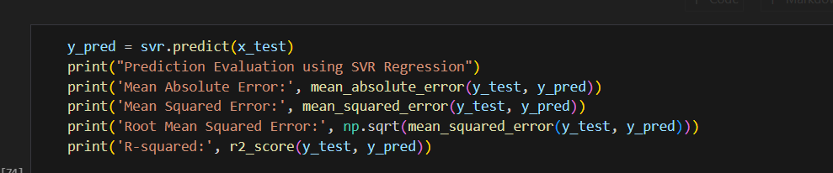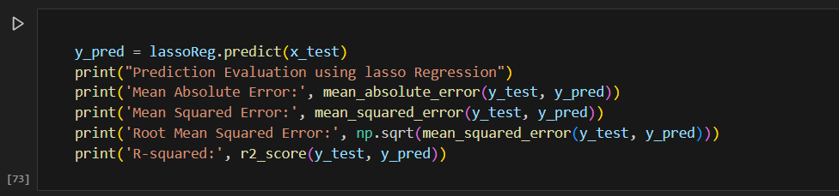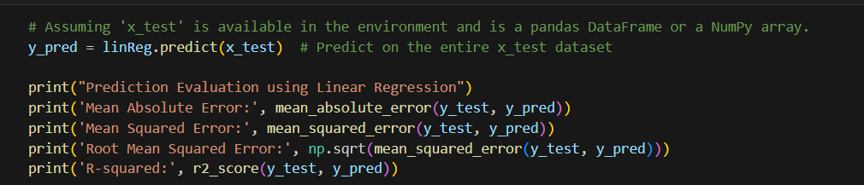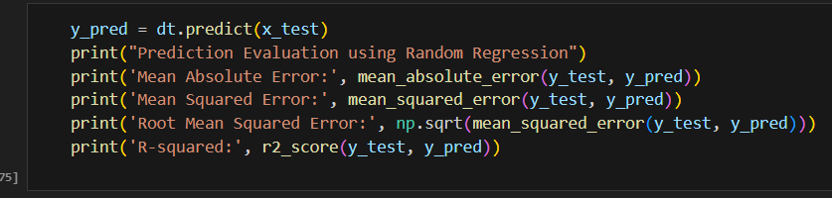

**Model Validation and Evaluation Report:**

|  |  |  |  |  |
| --- | --- | --- | --- | --- |
| **Model** | **Classification Report** |  | **Accuracy** |  |
| Random Forest |  | 0.86 |  |  |
| Linear regression |  | 0.30 |  |  |
| Lasso regression |  |  | -1.42 |  |
| Decision tree |  | -8.92 |  |  |